Navigating the Skies: A Mathematical Network Analysis of International Air Travel Dynamics (2000-2020)

Preyasi Gaur, Michael Bruynell, Manasi Indolikar

**Abstract**

This research paper employs mathematical network analysis to explore the dynamics of international air travel from 2000 to 2020. It investigates airport connectivity, the influence of major global events, and the roles played by airlines on ticket pricing. The study has the potential to unveil crucial insights into the economics of air traffic over the past two decades. The research delves into the aviation industry’s evolution and the impact of significant events (such as 9/11, economic crises, and pandemics) through the application of mathematical network analysis of the data to uncover intricate patterns of changes. Utilizing techniques like PageRank and degree centrality, we identify important airports and examine their correlations with air ticket pricing. Additionally, we analyze how network dynamics shifted during global disruptions, notably the COVID-19 pandemic and the Great Recession, and the correlation of such events on ticket pricing.

**Introduction**

Over the past two decades, international air travel has evolved significantly, driven by changing passenger mobility patterns and global events. This research paper focuses on the period from 2000 to 2020, using mathematical network analysis to study airline ticket pricing dynamics. The aviation industry, once a niche, has expanded rapidly, becoming a vital part of global connectivity and economic development. This growth has brought both opportunities and challenges. Events like 9/11, economic crises, and the COVID-19 pandemic have left lasting impacts on international air travel. Understanding how these changes have affected ticket pricing is essential for airlines, policymakers, and regulators, aiding in strategy adjustments and promoting pricing transparency. This paper conducts a longitudinal exploration of the airline industry's transformative trends, highlighting the impact of pivotal events and examining the evolving connections within the global air travel network. It explores airport connectivity, airline roles, and the influence of major global events on this complex ecosystem. Mathematical network analysis techniques like PageRank and degree centrality help identify major airports and their relationship with ticket pricing changes, revealing correlations between these factors. More specifically, it aims to address the following research question- the correlation between ticket pricing and international airport network by identifying ket hub airports, connectivity over time and effects of network disruptions. The research can be useful for the policymakers, researchers and airline business to understand the trends of air travel pricing for protecting consumer interest and devise airline strategies.

**Background**

Given the widespread popularity of air travel, exploration of the factors influencing ticket pricing has been a subject of substantial interest. Numerous researchers and experts have delved into the elements of airfare dynamics. For instance, Dechang Lin (2022) explored the effect of negative events like Russia- Ukraine conflict and the onset of the COVID-19 pandemic on air fares. The present study also aims to examine the factors that affect air ticket pricing, however the focus is on the dynamic nature of an airline network that could lead to pricing fluctuations. The study is conducted by employing network analysis of empirical data to contribute additional insight on this topic.

**Dataset Availability**

The following data was used for analysis in this project:

1. International Air Travel Dataset (1990 - 2023): From the U.S. Bureau of Transportation Statistics website which can be accessed at: <https://data.transportation.gov/Aviation/International_Report_Passengers/xgub-n9bw>   
   The dataset contains information on all nonstop commercial passenger traffic between U.S. airports and international points. We used a subset of this data set for years 2000-2020 for our research. The data set has information on the following columns:
   1. Passenger Information: Information regarding the number of passengers traveling on the flights.
   2. Flight Details: Data related to the points of connectivity (domestic and international).
   3. Airlines and Carriers: Details about carriers operating international flights.
   4. Airport Information: Information about international airports.
   5. Time Series Data: Time-stamped data to track changes and trends in international air travel over the years.
2. Global Airports Location Data: This data was used to create a visual graph of the airport network and can be found at: <https://www.partow.net/miscellaneous/airportdatabase/>

This dataset has information on the following:

* 1. General details about airports, ICAO code, IATA code, Name, Country, City, Latitude-Longitude position, Altitude

1. The Best and Worst Airports by Cost for International Travel: This is an article by Washington Post and can be found at: <https://www.washingtonpost.com/travel/2022/09/27/airports-cheap-flights-abroad/>

This article was used as reference for the least and most expensive airports for domestic travel for the deterministic analysis of the most and least important airports in the network. It is based on Scott’s Cheap Flights (<https://www.going.com/flights>).

1. Average Domestic Air Fares: Available on the U.S. Bureau of Transportation Statistics website and can be accessed at:

<https://www.transtats.bts.gov/AIRFARES/>

The dataset provides extensive information on the average fares paid by passengers for domestic air travel within the United States. This dataset is a valuable resource for understanding the pricing dynamics of domestic flights and is often used for various analyses and research in the aviation and travel industry. The dataset contains information on the Year, Quarter U.S. Average (Current $), U.S. Average (Inflation-Adjusted $), Origin (Current $), Origin (Inflation-Adjusted $), Destination (Current $), Destination (Inflation-Adjusted $)

1. Average U.S. airfares fall to lowest price after COVID-19 pandemic: Available on Reuters and can be accessed at: <https://www.reuters.com/article/us-health-coronavirus-usa-airlines-idUSKBN29O25H/>

This article was used as reference for the fall of ticket prices during the COVID-19 Pandemic.

1. Airlines 'to lose $9bn’ as they fight to survive recession: Published by Guardian and can be accessed at: <https://www.theguardian.com/business/2009/jun/08/iata-airline-industry-losses>   
   This article was used as reference for the fall of ticket prices during the Great Recession.

**Theory**

In this research project, we delve into the correlation between airline network metrics and ticket pricing, using the following concepts.

1. Page Rank: Page Rank assesses the importance of a node based on both the quantity and quality of incoming links from other nodes in the network. Nodes with a multitude of high-quality inbound connections receive higher Page Rank scores, indicating greater significance. This algorithm operates on the premise that nodes with numerous vital connections inherently hold more importance. Page Rank is invaluable for evaluating the relative importance of webpages or nodes within a network.
2. Degree Centrality: Degree Centrality serves as a fundamental measure to gauge the centrality or prominence of a node in a network, be it a person, an airport, or a webpage. It quantifies the number of connections or edges a node possesses relative to the total potential connections. Nodes with high degree centrality act as pivotal hubs within the network, boasting numerous connections, while those with low degree centrality exhibit fewer connections. Degree centrality holds utility in discerning the structural significance of nodes across a spectrum of networks, from social to transportation, aiding in the identification of influential elements or key players.

Utilizing these metrics, we ascertain critical airports within the network and investigate their correlation with ticket pricing. Additionally, we performed temporal connectivity analysis using Python modules. Furthermore, we employ three essential metrics and track their transformations throughout these crisis periods:

1. Network Density: Network density provides crucial insights into the level of interconnectivity and activity among airports with respect to flight routes. Elevated network density signifies a heightened utilization of potential flight connections between airports. Network density is
$D = \frac{Number of Actual Connections}{Number of Total Possible Connections}$

2. Average Degree: The average degree(k) is a fundamental network metric, evaluating the number of connections (edges) that each node (airport) maintains with other nodes. In airport networks, it is the average count of direct flight routes originating from each airport and is computed as summing the degrees of all airports and dividing by the total number of airports in the network.
$k = \frac{Total Number of Connections}{Number of Nodes}$

3. Communities: The concept of communities revolves around the identification of clusters of airports that exhibit robust connections and interactions. Such interactions often stem from factors like geographical proximity, airline alliances, or shared operational characteristics. Recognizing communities within the airport network aids in comprehending how airports cluster based on their unique connectivity patterns.

**Methods**

In this section, we detail our approach to analyzing the impact of two significant global disruptions, the Great Recession (2007-2008) and the COVID-19 Pandemic (2019-2020), on the international airline network, and how these disruptions influenced ticket pricing dynamics. We employ three key metrics as defined above: Network Density, Average Degree, and Communities to comprehensively understand and track the evolution of the network during these crises.

Network Density: It provides insights into how well-connected and active airports are in terms of flight routes. A higher network density indicates a more efficient utilization of potential flight connections between airports. To analyze network density during the the specific years (2008-2009) and (2019-2020) we followed these steps:

1. We extracted the passenger travel data for these periods, which encapsulated this economic downturn period and sort it chronologically by year and month.
2. For each month, we constructed a network using the NetworkX library in Python, with airports as nodes and flight routes as edges.
3. Network density was calculated for each month, allowing us to visualize how interconnectivity in the international airline network changed over this period.

Average Degree: In the context of airport networks, it provides an average count of direct flight routes originating from each airport. To examine the average degree during the Great Recession and COVID-19 Pandemic we undertook the following steps:

1. We used the same passenger travel data for the years 2008-2009 and 2019-2020.
2. Similar to the network density analysis, the data was sorted chronologically.
3. For each month, we constructed a network.
4. Average degree was calculated for each month, revealing how airport connectivity evolved during the economic downturn.

Communities: Communities refer to groups of airports that exhibit strong connections or interactions with each other within the network. Identifying communities aids in understanding how airports cluster based on their connectivity patterns. To detect and visualize communities during the Great Recession and the COVID-19 Pandemic , we implemented the following procedure:

1. We created separate network graphs for December 2008 (a month during the recession's peak) and August 2009 (after the recession).
2. Using the Louvain method from the community library, we partitioned the airports into distinct communities based on their connectivity.
3. Visualization of these communities was carried out, providing insights into how airport connections and community structures changed between the peak of the recession and the post-recession period.

The network density, average degree, and community structure analyses provide a comprehensive understanding of how the international airline network transformed during the Great Recession and the COVID-19 Pandemic.

**Results**

The Great Recession (2008-2009)

1. Network Density: The network density graph of the international airline network during the Great Recession (2008-2009) (*Figure 1*) reveals significant fluctuations. Notably, there is a consistent decline in network density from early 2008 to mid-2009, signifying reduced interconnectivity, possibly due to airlines cutting routes in response to dwindling demand. Sharp drops followed by recoveries at various points may reflect airlines adjusting capacities for seasonal demand or cost-cutting measures. The steepest decline occurs towards the end of 2008 and early 2009, coinciding with the peak of the financial crisis. The gradual recovery from mid-2009 indicates a slow industry rebound.
2. Average Degree: The average degree graph for the international airline network during the Great Recession (2008-2009) (*Figure 2*) offers valuable insights into airport connectivity. Initially, there's a decline in average degree in early 2008, suggesting airlines were trimming less profitable routes. Throughout 2008, the graph exhibits volatility but shows an upward trend later in the year, likely reflecting network adjustments to changing demand and economic conditions. A sharp drop in early 2009 corresponds to significant network contraction amid economic challenges. From mid-2009, a recovery is visible, indicating airlines were cautiously resuming operations.
3. Communities:

| December 2008 | August 2009 |
| --- | --- |
| The network shows a densely connected core with multiple communities. This suggests that despite the economic downturn beginning in 2008, the network maintained a relatively interconnected structure with multiple active routes. | By August 2009, the network's core appeared to have fewer communities, suggesting consolidation. This could be due to airlines reducing the number of routes and focusing on maintaining major, profitable connections. |
| There are a few isolated nodes far from the network's core, which could represent airports that had significantly fewer connections and possibly faced reduced flight operations. | The network seems less dense, with fewer peripheral nodes, indicating a reduction in the overall number of active routes. |
| The presence of small, separate clusters indicates specialized routes that persisted despite overall industry downturns, possibly due to essential travel or sustained demand on specific routes. | The isolated nodes seem to represent outliers or airports that were particularly hard hit by reduced flight operations, potentially due to airlines focusing on core routes to larger hubs. |

During the Great Recession, which occurred from 2007 to 2009, the airline industry experienced a significant downturn in passenger demand. Many travelers were cutting back on discretionary spending, leading to reduced bookings and empty seats on flights. Airlines responded by implementing various strategies to maintain profitability. This is reflected in the volatility of both the network density and the average degree over time curves depicted above. We can clearly see that there were periods during the Great Recession when there was an uptick in international air travel nodes, and there was downtick too. The upticks can be explained by lower prices to stimulate demand, however with the increasing layoffs, and rising fuel costs, the low ticket prices were not sustainable which led to a crumbling of the network, i.e. the downticks. The community graph also represents the increased consolidation of the network in August 2009 as compared to December 2008. The consolidation represents that only key components (the most important) are retained, and it reflects airlines' strategies to reduce costs by focusing on core routes and hubs, leading to a decrease in direct flights to smaller, less central airports.

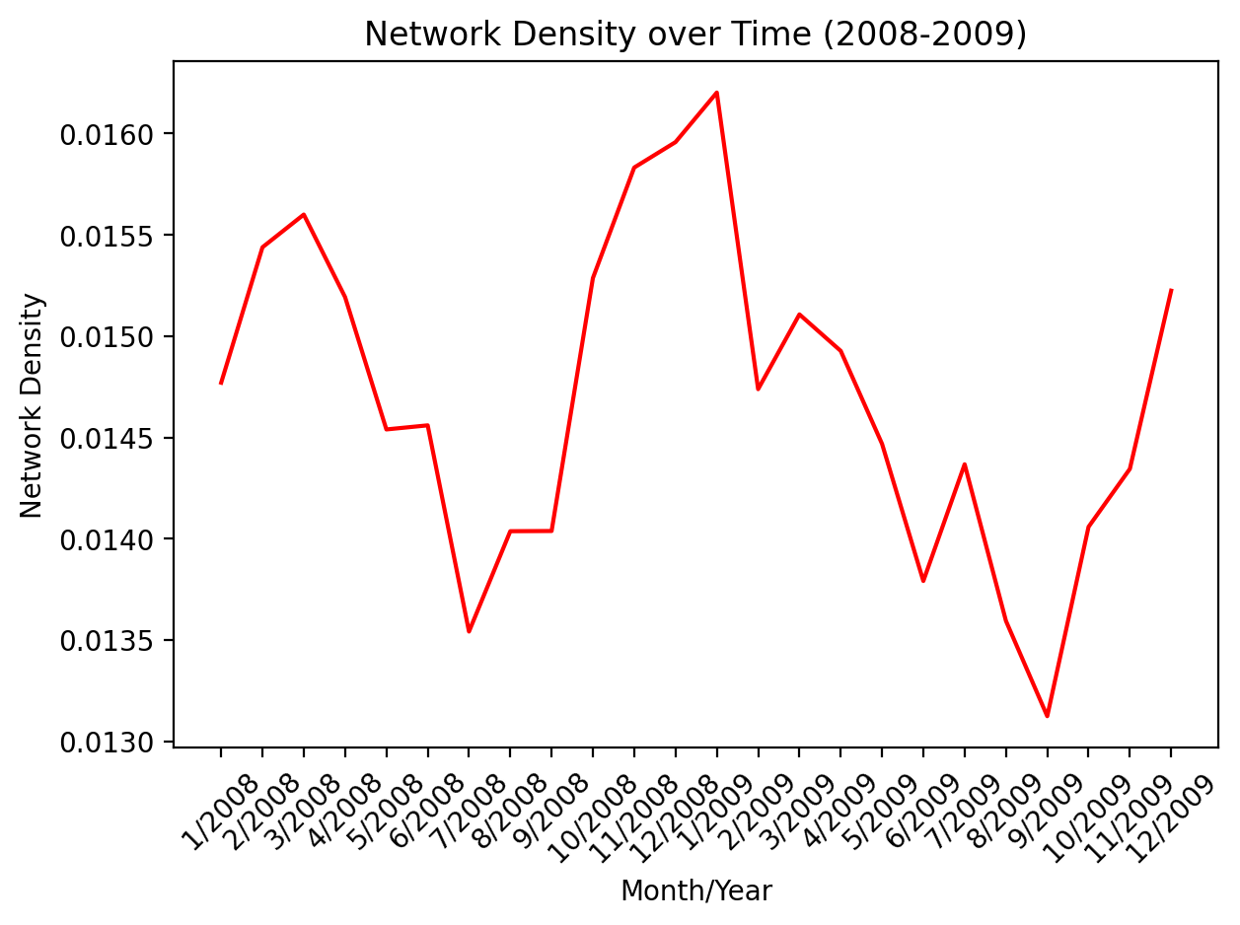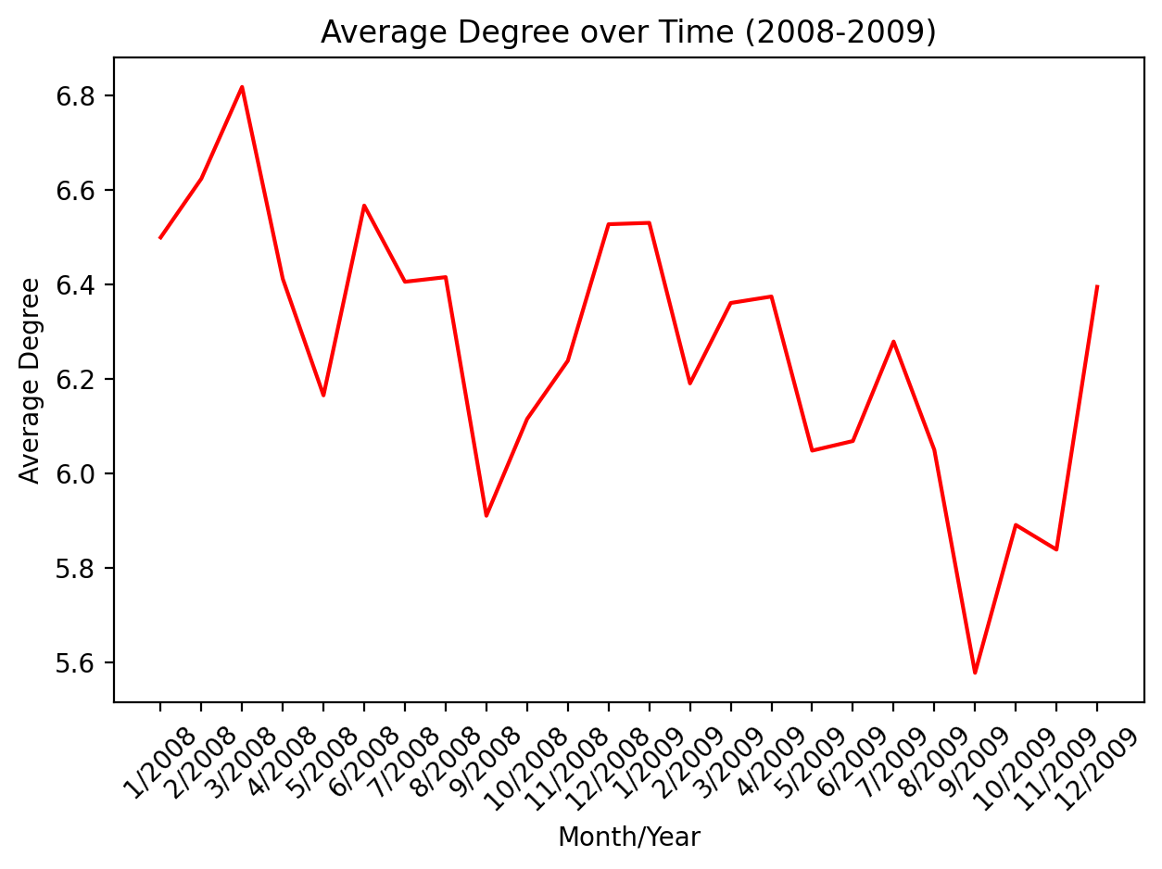

*Figure 1 Figure 2*

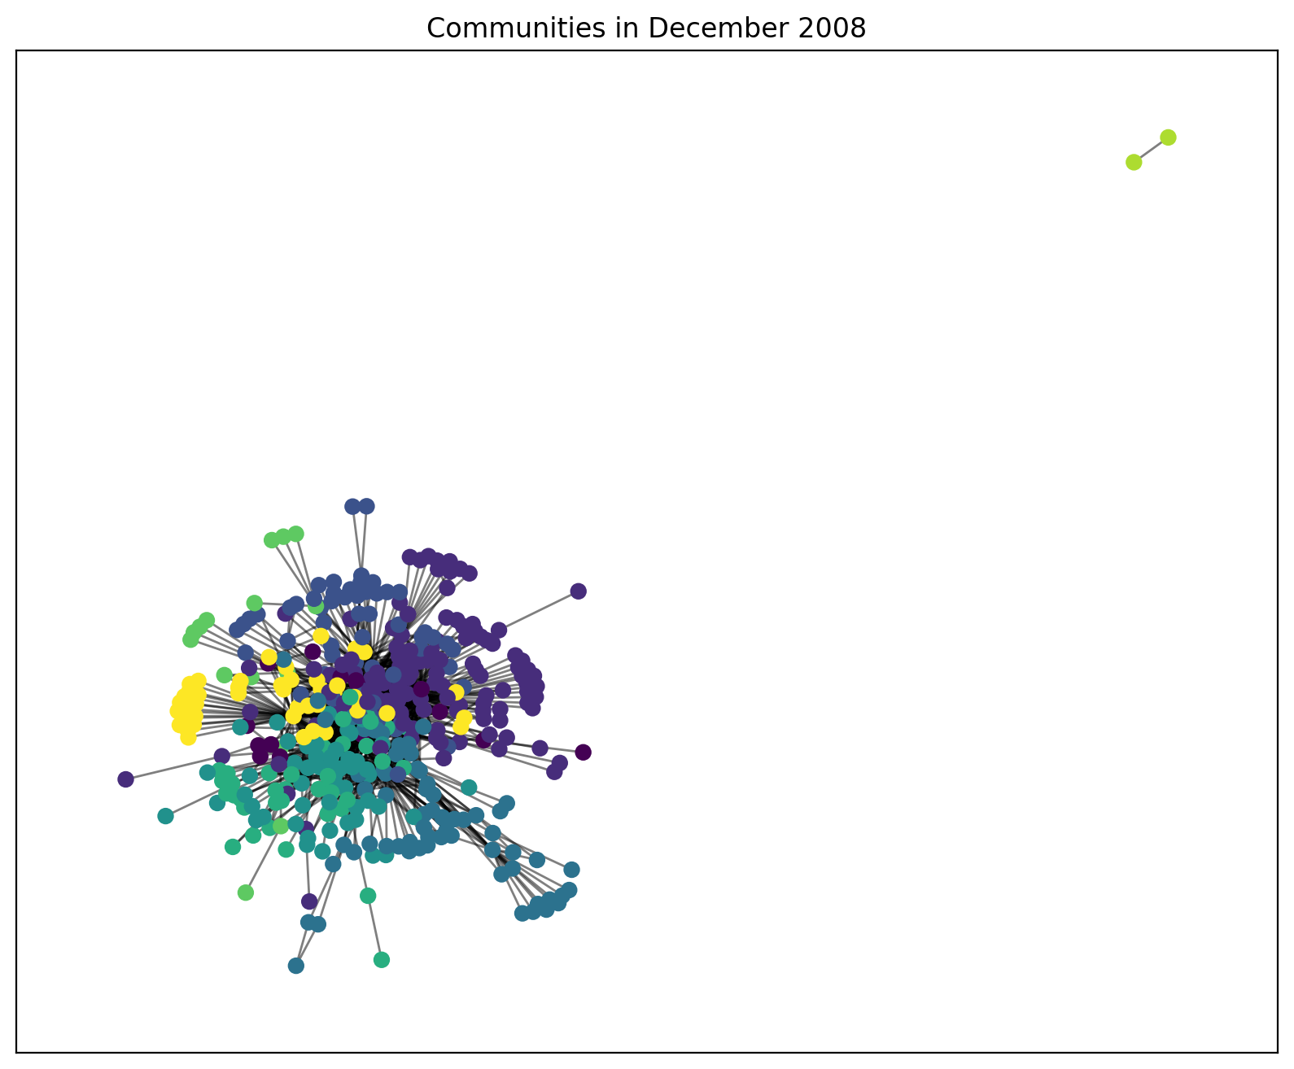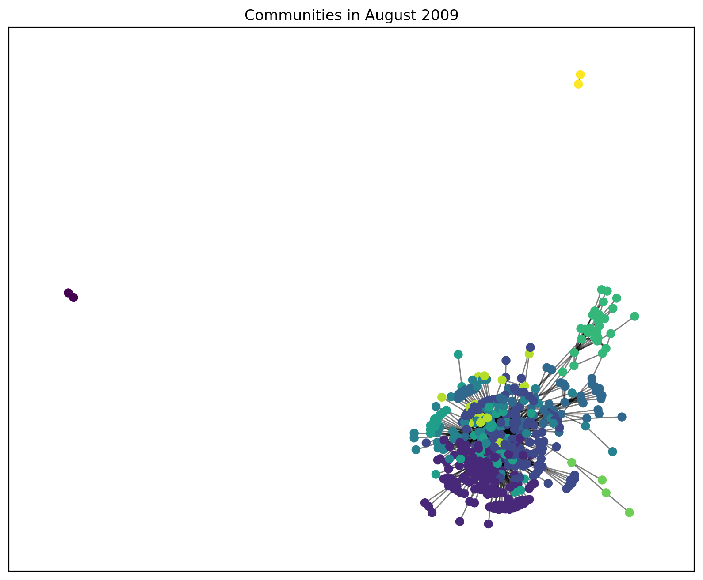

*Figure 3 Figure 4*

The COVID-19 Pandemic

1. Network Density: The network density graph for the airline network during the COVID-19 pandemic period (2019-2020) (*Figure 5*) displays notable variations in network connectivity. Initially stable in early 2019, the graph shows a gradual decline from mid-2019, signaling route reductions as airlines react to emerging pandemic concerns. At the start of 2020, a sharp drop corresponds to the pandemic's global recognition, indicating widespread flight cancellations and route suspensions. A slight recovery in mid-2020 follows as airlines adapt to new travel protocols. Late 2020 sees a noticeable increase in network density, possibly due to eased restrictions or route reinstatements.
2. Average Degree: The average degree graph of the airline network during the COVID-19 pandemic (2019-2020) (*Figure 6*) highlights significant shifts in airport connectivity. Initially, 2019 shows a stable average degree, reflecting consistent connectivity. In early 2020, there's a sharp drop, indicating airports lost connections due to pandemic-related flight cancellations and restrictions. The lowest point occurs around April to May 2020, aligning with the first pandemic wave's peak. Mid-2020 witnesses a gradual recovery as airlines cautiously resume operations. Late 2020 sees a substantial rebound, possibly due to route restoration or holiday travel. Reduced connectivity initially may have led to higher ticket prices, but overall demand decline forced price reductions. This graph illustrates the airline industry's adaptability amid pandemic uncertainties.
3. Communities:

| January 2019 | July 2020 |
| --- | --- |
| The network has a densely connected core where a large community is evident, with several smaller communities around it. | The central community appears more compact, potentially indicating a reduction in the number of flights and routes due to the impact of the COVID-19 pandemic. |
| There are various peripheral nodes with fewer connections, possibly representing less frequented airports or those with fewer direct flights. | There is a noticeable decrease in the size and number of peripheral communities, which could imply that many routes, especially international or less profitable ones, were cut. |
| The color variation within the central cluster could indicate multiple closely interlinked communities, suggesting a robust set of routes connecting different regions. | The network seems to have fewer nodes overall, which might reflect the cessation of operations at some airports or the removal of certain routes from the network. |

The COVID-19 pandemic, which began in early 2020, brought the airline industry to a virtual standstill. Travel restrictions, lockdowns, and fear of the virus led to a drastic drop in passenger numbers. Airlines were forced to ground a significant portion of their fleets, resulting in a substantial decrease in overall supply. As a result, ticket prices initially skyrocketed for the few remaining available flights, especially for essential travel. After a while though, due to limited routes, reduced demand and reduced competition, the prices stabilized. Airlines also introduced flexible booking policies and refunds to accommodate uncertain travel plans during the pandemic.

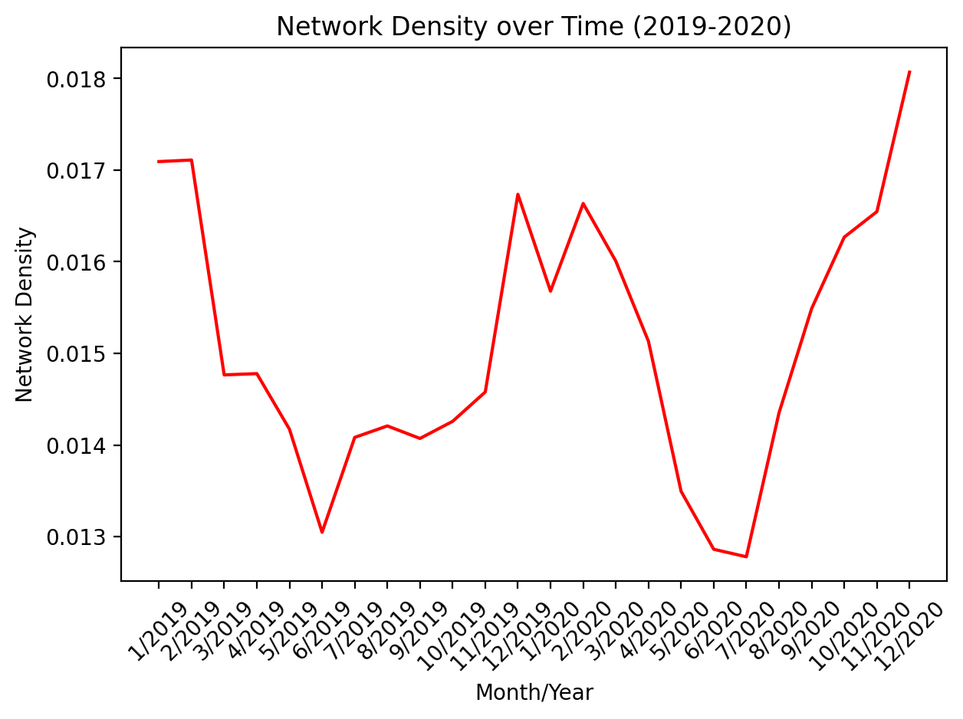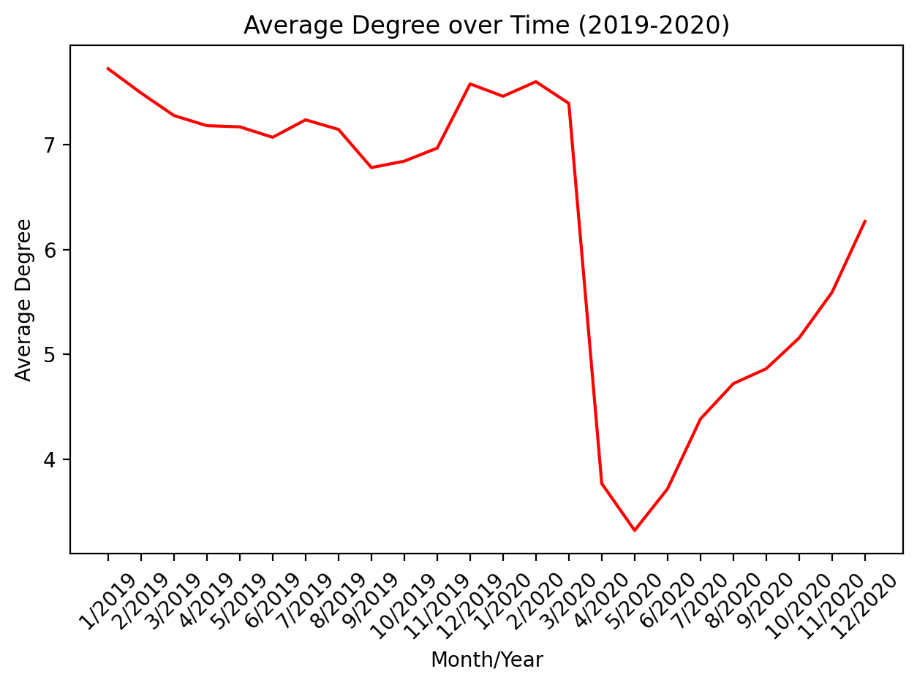

*Figure 5 Figure 6*

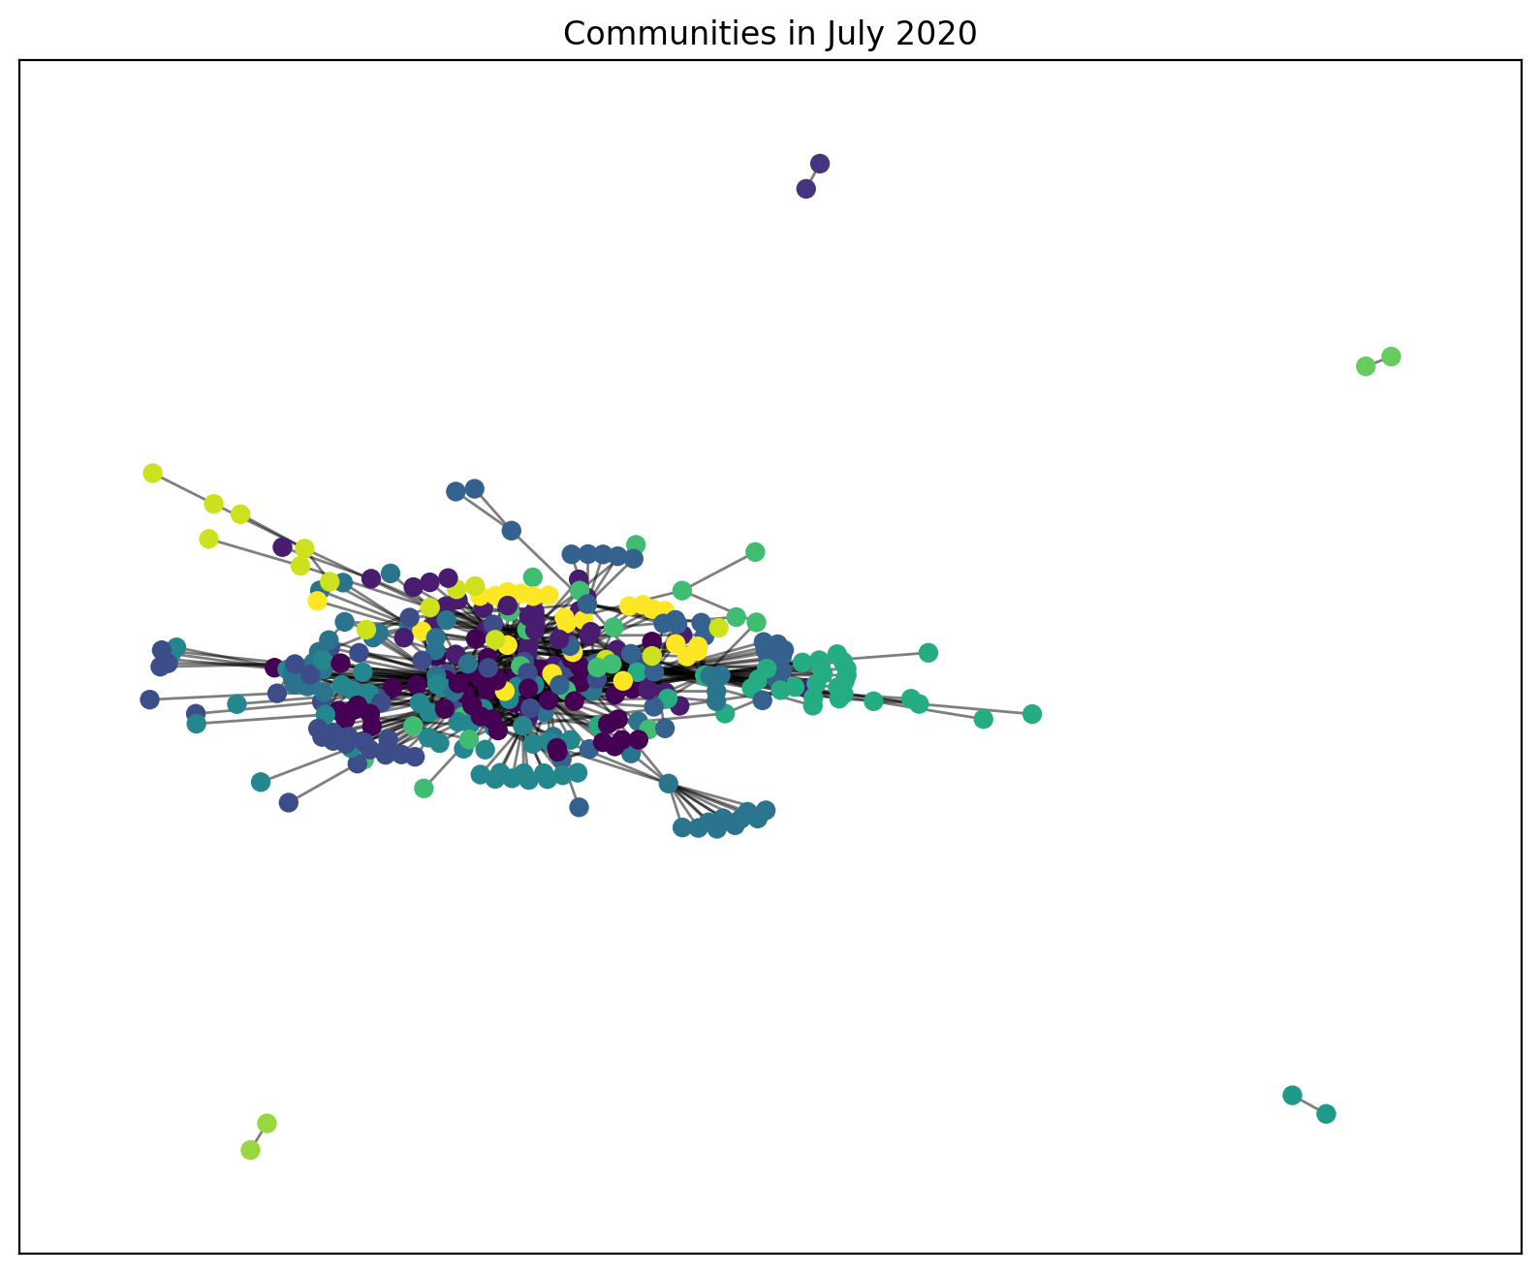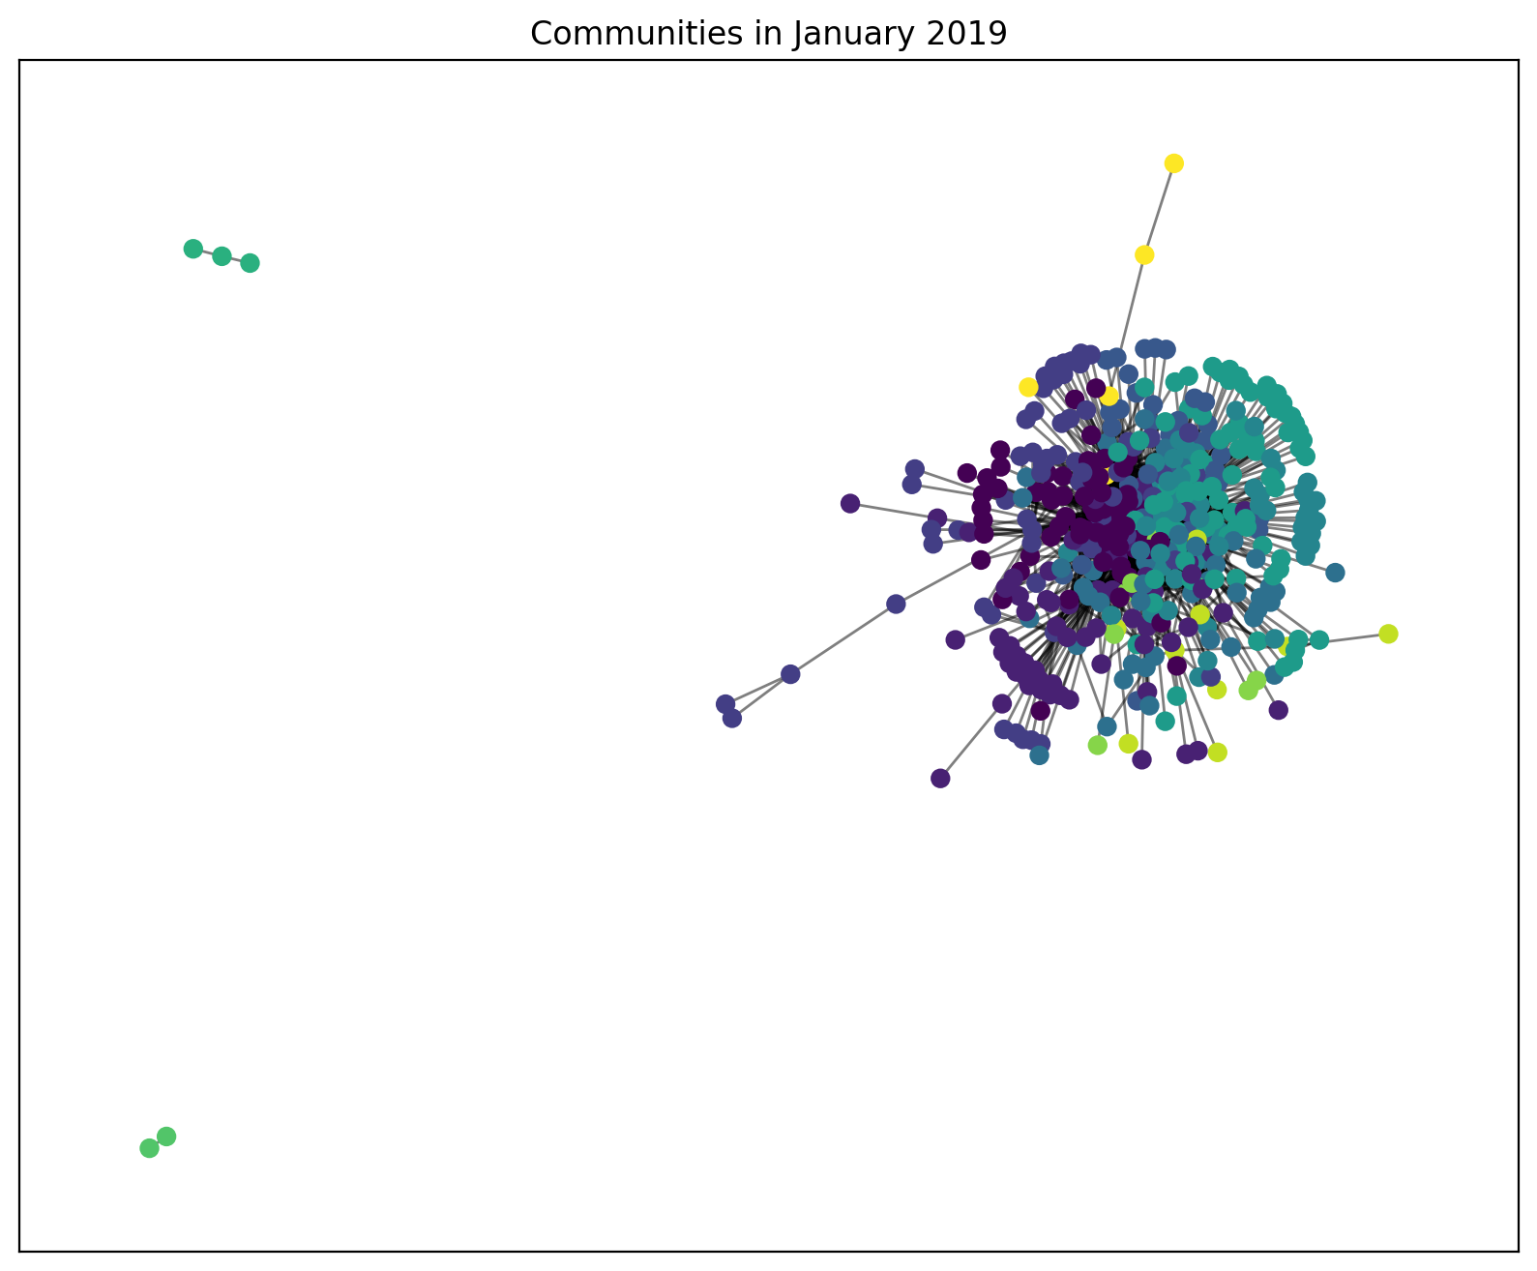

*Figure 7 Figure 8*

**Conclusion**

In our analysis of the international airline network during two significant periods, the Great Recession (2008-2009) and the COVID-19 pandemic (2019-2020), we know that airline ticket prices plummeted. Through analyzing network properties like average degree, network density and communities, we have tried to correlate the fall in ticket pricing to the shrinking of the subsequent network. We have observed distinct patterns and trends in network connectivity and airline ticket pricing. During the Great Recession, characterized by economic turbulence, we witnessed fluctuations in network density and average degree, reflecting airlines' efforts to adapt to changing demand and economic conditions. The consolidation of communities within the network suggested a focus on core routes and hubs to reduce costs.

In contrast, the COVID-19 pandemic brought about unprecedented challenges, leading to a sharp decline in network connectivity and average degree as airlines grappled with travel restrictions and passenger fears. The gradual recovery and rebound in late 2020 demonstrated the industry's adaptability amid uncertainty. The pandemic also initially led to price spikes due to reduced supply, followed by stabilization as demand waned.

Future research can be conducted on the long term effects of these global disruptions on the airline industry, a comparative analysis of how different components and areas respond to the crises, and resilience of the network in crises and how to improve the same.

Overall, our analysis underscores the airline industry's resilience in the face of economic downturns and global crises. It highlights the dynamic relationship between network connectivity, ticket pricing, and external factors, such as economic conditions and global events. These insights are invaluable for airlines, policymakers, and travelers seeking to navigate the ever-changing landscape of international air travel.

**Limitations**

Our research provides valuable insights into the correlation between airline network metrics and ticket pricing, but it has limitations. We use simplified network models that may not capture the airline industry's full complexity, including factors like competition, demand, and external events. We explore correlations, not causation, as external factors can influence ticket prices. Additionally, our analysis may not fully capture long-term trends or multifaceted factors contributing to airport significance.

**Contributions**

The development of our research question and hypothesis was led by Michael, Manasi, and Preyasi. Michael took charge of data research, diligently searching for relevant data to contribute to our research question. Manasi and Preyasi conducted a comprehensive literature review to ensure our work was grounded in existing knowledge. Preyasi formulated our analysis strategy and wrote the analysis code, with Michael subsequently reviewing the code. Manasi played a pivotal role in work planning and organization. Michael focused on making or improving plots and visualization tools, while Preyasi worked on enhancing teamwork and collaboration within our group. Michael also took on the responsibility of testing code and procedures, and finally, Manasi led the effort in writing our research report, summarizing our collective findings and contributions.

**References**

1. LUO, Li & PENG, Ji-hua. (2007). Dynamic Pricing Model for Airline Revenue Management under Competition. Systems Engineering - Theory & Practice. 27. 15-25. 10.1016/S1874-8651(08)60065-4.
2. Lin, Dechang. “Research on the Airline Industry Airfare Pricing Factors under Difficult Circumstances.” Proceedings of the 2022 2nd International Conference on Enterprise Management and Economic Development (ICEMED 2022), 2022.
3. Bikales, James. “The Best Airports for Cheap Flights Abroad, according to New Data.” Washington Post, 4 Oct. 2022, www.washingtonpost.com/travel/2022/09/27/airports-cheap-flights-abroad/. Accessed 4 Dec. 2023.
4. Shepardson, David. “Average U.S. Air Fares Fall to Lowest Price after COVID-19 Pandemic.” Reuters, 19 Jan. 2021, [www.reuters.com/article/us-health-coronavirus-usa-airlines-idUSKBN29O25H/](http://www.reuters.com/article/us-health-coronavirus-usa-airlines-idUSKBN29O25H/).
5. “Airlines ‘to Lose $9bn’ as They Fight to Survive Recession.” The Guardian, 8 June 2009, [www.theguardian.com/business/2009/jun/08/iata-airline-industry-losses](http://www.theguardian.com/business/2009/jun/08/iata-airline-industry-losses).
6. Garrow, Laurie, and Virginie Lurkin. “How COVID-19 Is Impacting and Reshaping the Airline Industry.” Journal of Revenue and Pricing Management, vol. 20, no. 1, Jan. 2021, <https://doi.org/10.1057/s41272-020-00271-1>.
7. Bureau, U., et al. “G L O B a L E c O N O M Y International Air Passenger Fares Shrug off the Recession.” STATISTICS, vol. 1, 2012, www.bls.gov/opub/btn/volume-1/pdf/international-air-passenger-fares-shrug-off-the-recession.pdf. Accessed 4 Dec. 2023.